**GMS Vendor Support JumpBox Access.**

# Part 1: Initial RSA Token set up

User must complete the following process to login to the GMS Vendor Support environment for the very first time.

**Step A**: From the start menu, select ‘Run’

**Step B**: Type in ‘mstsc’. Click OK

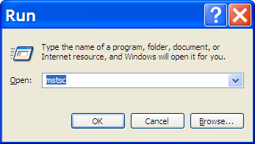

**Step C**: When the Remote Desktop Connection dialog box opens, type in one of the following IP addresses **172.26.173.160** OR **172.26.173.161**. Click ‘Connect’

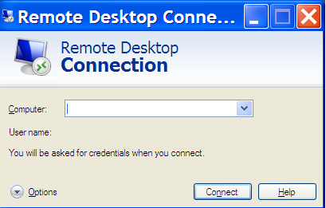

**Step D**: It will then bring up the following screen.

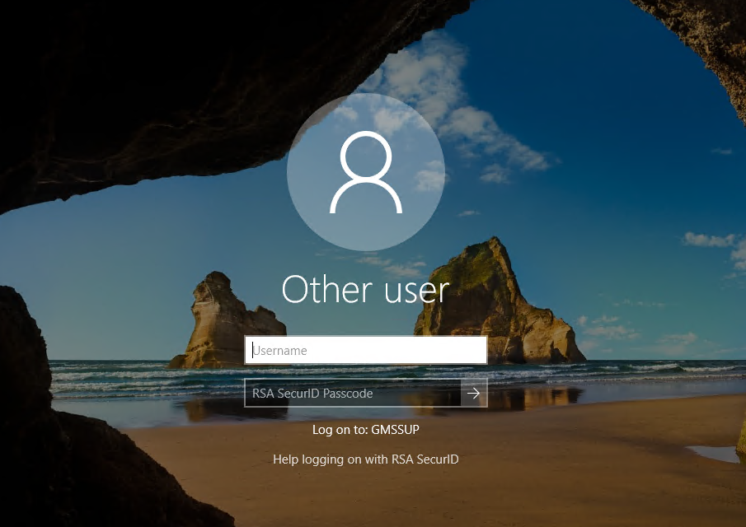

**Step E**: Type in your Active Directory user ID and token code. Please be sure to log in as yourself during this step.

User name: xxxxxx (xxxxxx = user ID)

Passcode: Enter the 6 digits number displayed on the RSA token



**Step F**: Create your personal PIN

Step 1: Under the PIN creation menu select ‘Create my own SecurID PIN’ and enter your personal (6 digit) PIN.

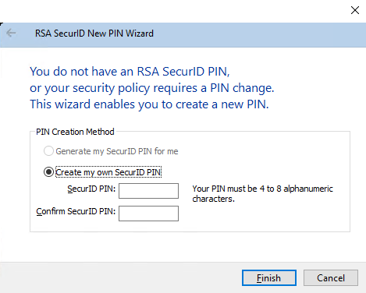

Step 3: Wait for a new 6 digit passcode to refresh on your token (max 60 seconds)

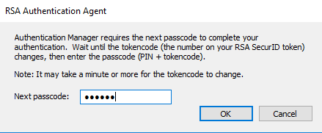

**Step F**: Provide Active Directory password from the following screen.

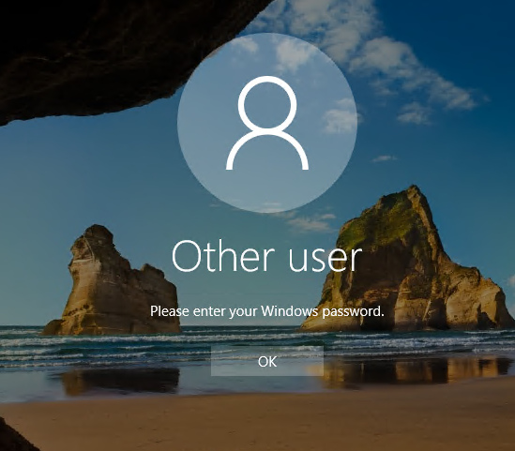

**Step G**: Please change Active Directory password when prompted.

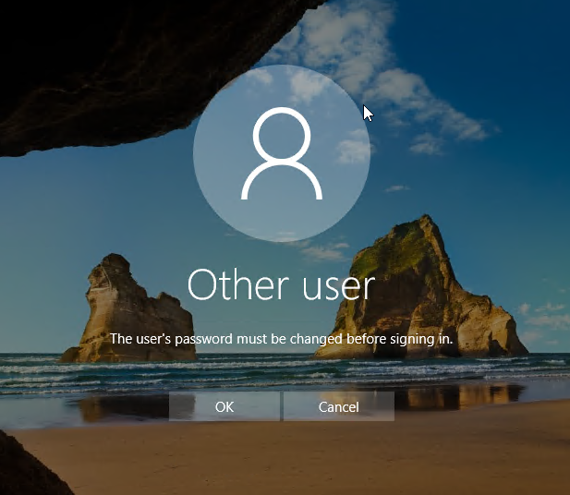

* For any issues accessing the Vendor Support access environment, please contact Won Choi at won.choi@sce.com or (626) 943-5742
* For further escalation, please contact Teresa Ong (IT PM) at [Teresa.ong@sce.com](mailto:Teresa.ong@sce.com) or (626) 476-6808.